Title of the Project



Site Address

INTRODUCTION OF THE PROJECT

Introduction of Website
This website is design to provide image defusion and ecncryption facilities to the existing users and new users according to their qualification, satisfaction and experience inside and outside the country. This website offers users encrypt and decrypt images according to their need.
Here we are using the technique in which Resolvers can obtain public keys of zones in one of two ways. Resolvers can utilize the image to query for the public key or they can be statically configured with the key. Regardless of the method used, problems exist with both. In the case where keys are obtained through the image, the issue of trusting the key arises. In order to trust the retrieved key, it must be signed and this signature must be reliable. Providing the assurance that the signature on the key is reliable means that the public key of the signing authority must also be obtained, be signed, and be found reliable and so on. The solution to ending this recursive chain of events is to configure the resolver with the public key that authenticates the signed keys below it. In other words, a trusted zone key can be used as a starting point for verifying all keys found below it.

OBJECTIVE OF THE PROJECT

Objective of Designing the Website
Crypto system is responsible for encrypting the user’s data and provide a secure mechanism to store it in a virtual drive. This virtual drive will be created by the system for the particular user for the very first while using the system. This system will provide limited storage area where the data can be saved. As we can say that, it’s a cloud storage medium where data can be accessed from any location. This system will also enable you to synchronize your desktop or laptop while using this crypto system. For implementing security mechanism, each user’s should have a valid login id and password and the verification of user’s account will be done through their valid email id.Upon accessing this crypto system, users can simply drag and drop their documents from their system to their virtual hard drive where it will take some time for encrypting the documents and process of encryption and decryption will depend upon the size of document and their type. User friendly interface has been provided, so that users can easily access all the provided features. It uses strong bit encryption mechanism and its virtual hard drive and easily loaded and unloaded at any location as per the user’s choice.

PROJECT CATEGORY

Web Based Application with RDBMS
HARDWARE AND SOFTWARE SPECIFICATION

Hardware Requirement
Processor 1.2 GHz (or above)
Ram 128 MB (or above)
Monitor SVGA
Pointing device Mouse
Hard disk 10 GB (or above)
Software Requirement
Operating System Windows 2007/2008/2010
Front End Language

- J2EE Java2 (jdk1.6,1.7,1.8)
- Java Server Pages (JSP)
- Servlet
- Hibernate
- Extensible Markup Language (XML)
Application Server Tomcat8.0
RDBMS Oracle 0g
RAD Tools Notepad
HTML Editor Macromedia Dreamweaver MX
Scripting Language Java Script

DATA FLOW DIAGRAM

Context Level DFD

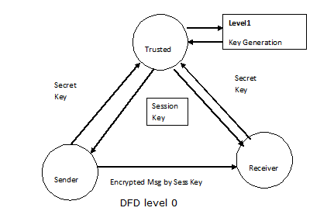

Second Level DFD

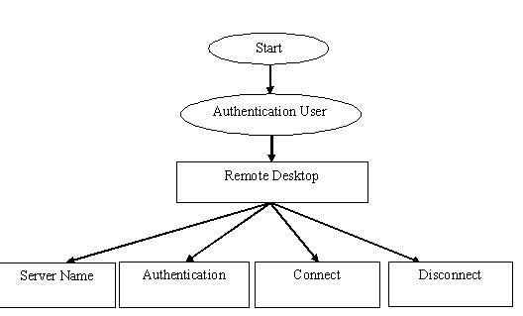

ER- DIAGRAM

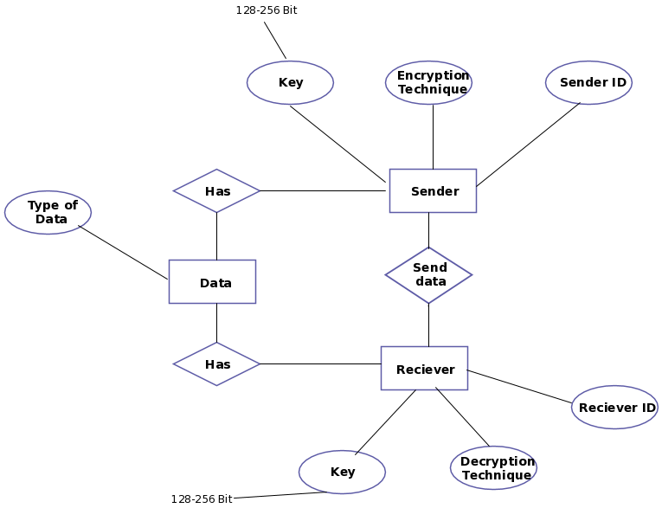

MODULE

INTERACTION BETWEEN MODULE
- User
- Fusion and Defusion
- Encryption and Decrytion
- Chat

MODULE DESCRIPTION

INTERACTION BETWEEN MODULE
- User
This module keeps the records of its all users i.e. their names, their qualification, their key skills,and address of residence.
- Fusion and Defusion
This module helps the user for fusing and defusing the image. User can fuse or defuse the image according to need, preferred image, client, Skills and size.
- Encryption and Decrytion
This module helps the user for encrypting and decrypting the image. User can encrypt or decrypt the image according to need, preferred image, client, Skills and size.
- Chat
This module helps the one user and othe online users to interact with each other. This module avoids the face-to-face interaction because it provides the facility of online interaction. Online interaction means one online user asks the question to the other online users by the internet from different location and others response in same manner.

DATA STRUCTURE

Table Name: User_Info

Attributes | Field Type | Field Size | Constraints | Description
FName | Varchar2 | 15 | Not Null | It has user first name
LName | Varchar2 | 30 | Not Null | It has user last name
Gender | Varchar2 | 15 | Not null | It has user gender
Email | Varchar2 | 15 | primary key | It has user email address
Password | Varchar2 | 8 |  | It has user login password

Table Name: Group_Chat

Attributes | Field Type | Field Size | Constraints | Description
Msg_From | Varchar2 | 15 | Not Null | It has online user name
Message | Varchar2 | 15 | Not Null | It has user message
Sent_Date | Date |  |  | It has the message sent date

PROCESS LOGIC

In This Project Home Page, Contain the Following Section
- Existing User Login
- New User Registration
Existing User Login
This section has a home page that contains the following:-
- User Id
- User Password
When User Login successfully, he will get the following facility
- Fuse/Defuse This option provides the facility to fuse and defuse the original image by using key image.
- Encrypt/Decrypt This option provides the facility to encrypt or decrypt image using the password key.
- Update Detail This option use to update the detail of user.
- Chat Forum This option will allow user to interact another user who are online at the current time and may exchange the solution about anything they want.
New User Registration
If a new user, wants to register in this site for job information enter in New User Registration Section by click on link New User Signup. After clicking on link, a register form will display which is filling up by the user.
Home-Page consist an another Section “Forget Password”
This section is design for providing the facility to user when he/she forget his/her password. When user enters in this section a security question, ask to him/her, which answer fill up by the user at the time of registration. If the answer match with the previous answer password will be show to user.
Validation checks must be defined in project to improve efficiency of project. Validation checks check the validity of input and output values. i.e. Whether the input and output are valid or not. Validation checks are called integrity constraints. Some commonly used integrity constraints are
- Not Null
- Primary Key
Now we will discuss some error messages that may be encountered while working with this project and necessary validations to avoid such errors.
1. Error Message Please check your password
- Description This message comes when password is wrong
- Validation User must enter correct password
2. Error Message Invalid E-mail
- Description This message comes when there is no @ symbol in E-mail address and E-mail address is wrong
- Validation User must enter valid E-mail ID
3. Error Message Field cannot be empty
- Description This message comes when we do not enter any detail while inserting Data
- Validation Not Null
4. Error Message User Id cannot be empty
- Description This message comes when we do not enter user ID
- Validation Not Null

REPORT GENERATION

Report generation facility is only available to Admin. Admin can generate the report according to requirement. Such type of report as following;-
- User Report: - This will generate the user report.
- Chat Report: - This will generate the chat report.
- Fusion Report: - This will generate the Fusion report.
- Encryption Report: - This will generate the encryption report.

SECURITY MECHANISMS

One of the most important aspects of any project is security mechanism. We use many securities to solve the unwanted person access.
Password
A password is a unique string of characters that a user types in as an identification code. The system compares the code against a stored list of authorized passwords and users. If the code is legitimate, the system allows the user access, at whatever security level has been approved for the owner of the password.
A password of the system is automatically kept by user and not easily traceable through at the development time this was avoided and it was only shared with database administrator and ask to change from time to time. All the forms and reports executables were kept on the server and shared by user to provide software consistency.
Security from Virus
A good virus scan program will check all the messages. If any mail will have virus this scanner will discard that mail automatically.
Database Security
A database Security s very important to secure their data for security practices for protecting Oracle database applications. These options are independent of any additional security measures at the operating system level.
Database supports several and methods of file protection:
User Oracle restriction
File open protection
You can set a password to control opening the database.
Source code protection
Database encryption
You can use database encryption to prevent unauthorized users from viewing the objects in an application with a disk editor or other utility program. You can use encryption in conjunction with all other methods of protecting an application.
User level security is the most flexible and secure method of protecting sensitive data, code, and object design in a database application developed in Oracle. In addition, user level security is the only form of Oracle security that allows you to establish different levels of Oracle to sensitive data and objects.

FUTURE SCOPE OF PROJECT

The project “CRYPTOGRAPHY” is generalized software and can be easily used in any consultancy department. The change in software can be easily accommodated.
The improvement in turnover of company up to any extent will be supported by software. The software will be able to provide its best facilities in case company starts online transactions in future. In this project, all the activities of the organization are performed manually.
To overcome all kind of problems being faced by organization. My project “CRYPTOGRAPHY” will provide efficient and cost effective solution and always have possibilities of enhancement up any legal extent to satisfy user requirement.
Further enhancement may include technical forum, Audio Encryption, mailing server/voice mail & Video Encryption and some extended modules.

